Home Work 3: Oracle SQL Class

# Homework Music: Instructions

Create the tables for this homework in the Books schema.

**ORDER OF OPERATIONS**

**When creating tables**

a. Create the parent table first (if more than 1 then either one)

b. Create the primary key on the parent table(s)

c. Create the child table

d. Create the primary key on the child table

e. Create the foreign ley on the child that points to the primary key on the parent(s)

**When adding data**

a. Add the parent records first (if more than 1 parent then either one)

b. If more than one parent exists add the next parent record next

c. Then add the child record using the primary key values from parent/parents

**When deleting data**

a. Delete the child record first

b. Then you can delete one or more parents if you need to in whichever order you like

# Homework Music: ER Diagram

Artist is parent to Song

Song is child to Artist

Song is parent to Track

Album is parent to Track

Track is child to Song

Track is child to Album

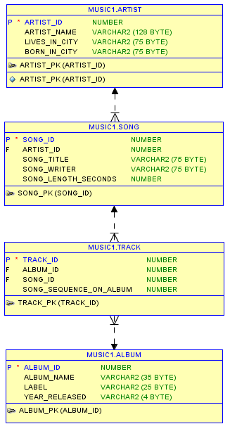

one to many

one to many

one to many



# Homework Music: Confirmation

Create the tables and constraints as discussed above. Insert the data for one of your own albums. Then copy and paste the SQL statements below into SQL developer.

Modify them to run against your own tables if necessary. (if you gave your fields names other than in the spreadsheet)

Create a Microsoft Word document called HW_3_Confirmation.doc. In the word document place the following items:

NOTE: To capture

1. Screenshot of: **No 1. SQL**

Then run the first query in SQL Developer. It will produce a result set in the bottom right window. Use your mouse to slide over all of the cells in the SQL Developer output window to select the output, then press CTRL-C to copy the results set to the clipboard. Then move your mouse over the Microsoft Word window and click CTRL-V to paste the results set under Query No. 1 in the word document. (don’t worry if you do not paste the column headings or row numbers—just the data is fine).

Email me the HW_3_Confirmation.doc before Tuesday’s (May 31 class).

**-- ---------------------------------------------------**

**-- Homework Music: Confirmation**

**-- ---------------------------------------------------**

**-- No 1. SQL. List all artist’s names**

**select user, sysdate, artist_name**

**from artist;**

**-- Copy and paste this SQL with the results from SQL Developer**

**-- into a Word doc**

**-- ---------------------------------------------------**

**-- No 2. SQL Query. List song titles, artist's name for every**

**-- song you have and sort the list by song title**

**select user, sysdate, artist_name, song_title**

**from artist ar, song s**

**where ar.artist_id = s.artist_id**

**order by song_title;**

**-- Copy and paste the SQL with SQL Developer results into the**

**-- same Word doc as No.1**

**-- ---------------------------------------------------**

**-- 3.Question. List the album name and song titles for each album**

**-- and sort by album_name**

**select user, sysdate, album_name, song_title**

**from song s, track t, album al**

**where s.song_id = t.song_id**

**and t.album_id = al.album_id**

**order by album_name;**

**-- Copy and paste the SQL with SQL Developer results**

**-- into the same Word doc as No.1**

**-- ---------------------------------------------------**

**-- 4.Question. You are trying to decide if you want to**

**-- buy another album from an artist you already have**

**-- in your collection.**

**-- So list artist_name, album_name, song_title for every album**

**-- you have for that artist.**

**-- I will use Cher. Change Cher in the following query**

**-- to an artist in your database. Remember the artist name**

**-- must be the same case as your data in the table**

**select user, sysdate, artist_name, album_name, song_title**

**from artist ar, song s, track t, album al**

**where ar.artist_id = s.artist_id**

**and s.song_id = t.song_id**

**and t.album_id = al.album_id**

**and artist_name = 'Cher';**

**-- Copy and paste the SQL with SQL Developer results into the Word doc**

**-- ---------------------------------------------------**